# **Cuba: *Videos to the left –* circumvention practices and audiovisual ecologies**

**Fidel A. Rodriguez**

**DATA BOX**

30%: Proportion of Cubans aged 16-54 who have access to the Internet

$2: Hourly cost for a 100 Mbit/s fiber connection in CUC/USD

0%: Proportion of internet users who made online purchases in 2014 from Cuban accounts

0%: Proportion of internet users who paid for a video streaming service in 2014 from Cuban accounts

**QUOTES**

“Starting today, people in Cuba with Internet connections and access to international payment methods will be able to subscribe to Netflix and instantly watch a curated selection of popular movies and TV shows.” – Netflix press release, 9 February 2015

Havana, January 2015. A young reggaeton singer is detained by the police in a luxurious house on the outskirts of the city. The arrest is quickly reported in foreign news media outlets, with Reuters first breaking the story. These reports describe a pending court case in Florida, involving alleged major fraud of the U.S. Medicare health program. Photos of the singer’s extravagant lifestyle are published in the media, where he poses with bundles of cash and firearms.

The singer’s arrest is captured by bystanders and neighbors on mobile phones. While there is no coverage of the arrest in the Cuban media, amateur videos soon begin to circulate via unregulated wifi networks that operate across Havana. A few days later, another video appears on YouTube, this time recorded by a motorcyclist who was driving by the scene of the arrest. In the following weeks, a recording of the singer’s police interview also starts to circulate across the city, passed around through USB drives. Finally, these materials make their way into commercial pirate distribution, appearing as a folder in *el paquete* (‘the package’) – a regularly updated compilation of pirated video and music files that is circulated across Cuba through thousands of local redistributors.

The story of Gilbert Man, the stage name of the artist in question, reveals how video circulates informally in Cuba today. Geoblocking is not a major issue for Cubans – slow internet connections make video streaming almost impossible, and access is mostly limited to government offices and institutions – but circumvention is a mainstream, everyday practice. Recent years have seen the emergence, *a la izquierda* (‘to the left’), of a surprising ecology of transnational video circulation practices making use of diverse technological workarounds. These processes draw attention to the transformation of media access in the country, in the context of an expanding but still limited internet infrastructure. They also reflect the distinctive media geography of Cuba, which partakes in global flows of digital video content, but in a unique way that combines networked and offline distribution systems.

The term ‘to the left’ does not refer to a party-political position in Cuban everyday speech. Ironically, it refers to all types of non-formal methods to access goods or services. This phrase has become popular since the 1990s, referring to the economic struggle of ordinary people. It evokes the Cuban style of proxy access to all sites, through all connections.

## Skipping back: revolution, videos and access

Universal access to culture has been a foundational ideal of the Cuban revolutionary project since 1959. As part of the political demands of the new era,[1] cinema production became a priority for the government, and a national institute dedicated to cinema – the Instituto Cubano del Arte y la Industria Cinematográficos – was founded in April 1959. In practice, this vision was undermined by the economic and political ruptures of the Cold War. During the 1960s, Cuban policymakers approved the use of unlicensed cultural materials – including foreign copyrighted materials such as movies and books – as they were seen to be valuable for the cultural development of the nation. However, this universal vision of access coexists with state regulation of culture and media, according to the political programme of the Communist Party. This policy limits access to audiovisual content to officially sanctioned government spaces and facilities.

In response, a massive, extra-legal culture of media circulation has emerged. Officially banned movies are widely available, leading to much public debate about censorship. State-run TV channels screen pirated HBO programming on a daily basis. Despite the increasing cost of living, TVs, DVD players and digital devices for recording and playback can be purchased privately and are no longer distributed by the state. The acquisition and use of this equipment has become an important status symbol for Cuban families.[2]

Until 2007, the sale of VHS or CD/DVD equipment was illegal. Nonetheless, private video rental outlets proliferated across the country. Despite their illegal status they were generally tolerated by the authorities. For the first time, these practices put private citizens and household businesses in a social environment of audiovisual consumption, and relocated media consumption to private spaces.[3]

In the pre-digital period, a small official VHS movie rental and sales circuit existed in Cuba, but prices were prohibitively expensive for most people. Hotels and shopping centers stocked a small selection of prestige Cuban movies on VHS, with pricing aimed at the tourist market. Another program in the early 2000s established movie rental facilities in some theaters, featuring a catalog of quality titles, but lacking of the variety of the private video stores. Aside from a few other small-scale initiatives, these are the only authorized systems of home video distribution organized by the Cuban government. The few video-streaming repositories managed by state institutions include only a small selection of titles, and do not carry the more popular Cuban productions.

In 2013, a landmark reform of economic regulation in Cuba allowed private sale of pirate CDs and DVDs in the streets, and specified the kinds of tax that such enterprises would pay. In the case of Cuban media the regulations permit public screening for noncommercial purposes and with the recognition of the authors. This system of sanctioned small-scale distribution continues today. It is a matter of some controversy, however, because some artists regard the system as tantamount to official sanctioning of piracy At the same time, “the pirate” does not exist as a criminal figure in Cuba.[4]

There have been other changes in Cuban media policy along the way. For example, in 2013 a new ruling led to the mass closure of private 3D cinemas, which had become popular in recent years – however two years later the government announced that some state-owned 3D cinemas would reopen across the country.

Another important practice is the acquisition of cable TV receivers, which are still illegal for Cuban citizens to own. This informal cable TV system in Cuba requires the installation of a modified receiver acquired on the black market, and operated on a sublease basis. Wiring is run through the roof and attached to the telephone wiring in areas near the signal receiver. These channel packages usually include American TV programming aimed at the Cuban community of emigrants in Miami. In 2007 and 2009, various investigations confirmed access to these services as a common cultural practice among families in different neighborhoods of Havana.[5]

Even when media devices like computers and HDD players are not available through shops, they can be acquired on the black market. Official statistics from 2014 suggest a very small percentage of private ownership of these items,[6] but the real figures are likely higher.

Since the 1980s the government has been involved in community ICT programmes, and these have also been instrumental in the daily experience of media and internet use in Cuba. One initiative, known as the Youth Computing Club, offers free or low-cost access to computers along with training in computer skills. These clubs are joined together in a national network that offers blogs and social networking sites, which also connects to other national internal networks linked to the educational and health sectors. Through membership of these networks, some Cubans are able to get online regularly – one example is the Infomed network of health workers who acquired free access to the internet in September 2015. This opening-up of internet access represents an important increase in the number of home connections. However, access is restricted to 25 hours a month, on a very low-speed connection. While networks such as these are limited by the infrastructure they use and the legal framework governing them, these home internet networks could nonetheless play a major role in the development of a nation-wide content-sharing platform.

## Internet dilemmas

Cuba has been connected to the internet by satellite since 1996, through a special license from the United States Department of Commerce, as an exception to the laws forbidding economic relations with the island. In 2012 – before the first optical fiber cable connection was established with Venezuela – Cuba’s connectivity rate was 458 Mbs input/229 Mbs output,[7] comparable to that of an apartment building in the United States. In light of the lack of available bandwidth and infrastructure the government’s official internet policy was to prioritise connectivity to government institutions and select user groups.[8] Hence the Cuban internet came to be officially understood as a repository of information, tools for electronic commerce and a means for information dissemination.[9] This approach to internet regulation was also shaped by the conflict with the United States, which has long funded projects involving ICTs as tools of political subversion to undermine the Cuban government.[10]

Personal use of social networking sites at government institutions was usually restricted or limited to low-traffic times. As a result, the practical knowledge of forms of proxy access to these sites became a shared secret. Nonetheless, for almost all Cubans the very slow internet speeds made social networking impossible until the wifi zones appeared in 2015 (see below).

In 2012, the state-owned telecommunications company ETECSA implemented the first open internet access service. Costing 4.50CUC per hour (US$5.10), the service was available at workstations in municipal offices, after registration of personal data. The price was extremely high, and even providers considered it excessive.[11] As a result, this initiative received much criticism. However, the Cuban First Vice President said in a national convention on ICTs and cybersecurity in January 2015 that the state was willing to extend open internet access across the country. This was followed by the announcement of a plan to connect all schools in Cuba and improve the internet infrastructure of universities, where limited access was already available. In July, ETECSA started a wireless internet service in 35 public spaces around Cuba at a price of 2CUC per hour.

This rate is still considered high, but has resulted in a substantial increase in use. According to the National Statistics Office, in 2014 there were 3 million internet users, representing 27 percent of the total population.[12] Nonetheless, Cuba still comes in at 160th place on the International Telecommunication Union’s ranking of global ICT use and access. These facts, combined with the country’s history of informal interchange and non-market cultural consumption, help to explain the diversity and complexity of video circulation practice in present-day Cuba, which interface with global networks but use primarily *offline* distribution methods within Cuba.

## Videos without time or space: ‘the package’

|  |
| --- |
|  |

In parallel to these structural constraints on internet access, various workarounds have emerged in Cuba. One well-documented phenomenon is USB sharing, which since the mid-2000s has become an efficient system for digital media circulation in Cuba.[13] Over time this form of distribution has become standardized in a commercial format known as *el paquete* (the package). These compilations comprise one terabyte of diverse media content – television, movies, software, magazines and music – all updated on a weekly basis. The *paquete* typically includes: the latest episodes of TV shows direct from the United States, Spain, Mexico, Brazil, and Colombia; a selection of new documentaries; Cuban television shows; the latest music videos; and multiple TV programs from Miami. According to one study, 35% of the Havana population (almost 3 million people) are regular consumers of *el paquete* – although a lot of people access it through friends for free.[14] The mysterious origin of the weekly *paquete* is a source of collective obsession in Cuba, because until 2015 there were very few places that had the bandwidth to download such a large amount of data. Nonetheless, different researchers have confirmed that content in the *paquete* comes fromhas diverse sources, from cable antennas to p2p download sites[15].

The price of the *paquete* is variable, depending on where you live and what day of the week you buy it.[16] The content selection within each weekly *paquete* is also variable, because distributors are known to add and remove videos as the *paquete* moves through the network, from the original compilers through to the high-level brokers (“first hands”, “big fishes”) and ultimately to street-level retail and rental sites. At each level, distributors – mostly part-time or temporary workers who have become involved in the *paquete* business to make some money on the side – may add or remove content to suit local tastes, meaning that the product is rebuilt at each stage. Although some *paquete* distributors have implemented feedback mechanisms to cater to their customers’ demand, user involvement in the selection of programming usually happens only during the final stage of street-level distribution.[17]



Fig. 1. An example of a *paquete*

Distribution of the *paquete* is typically carried out discreetly, often through licensed streetside DVD vendors or private photocopying and printing centres. These activities are widely tolerated by officials. Several high-ranking government figures have publicly stated that they do not intend to ban this trade. As a result, the *paquete* tradeis widespread in the streets as well as on digital networks. For example, in the Cuban online marketplace Revolico.com – a Craigslist-style classifieds site for Cubans which, ironically, is accessible only through proxies – dealers advertise their various offerings and freely offer their mobile phone numbers. Interestingly, the contents of the *paquete* often include scraped data from Revolico.com so that people without internet access can browse its listings.

The social significance of this phenomenon has led to a broad public debate on the topic, involving senior officials in Cuban cultural policy. The level of media coverage is unprecedented for an informal market activity. These discussions have drawn new attention to certain aspects of the Cuban media environment: copyright legislation and its implementation, national internet infrastructure, consumer education, cultural policy, and the status of Cuban audiovisual production. Quality of content and the protection of national culture are particularly popular topics of debate. As a result, in 2015 the aforementioned Youth Computing Club began to distribute (for free) a *paquete-*like compilation created by government-linked cultural organizations, offering a selection of pirated ‘quality’ content, including movies and TV series.

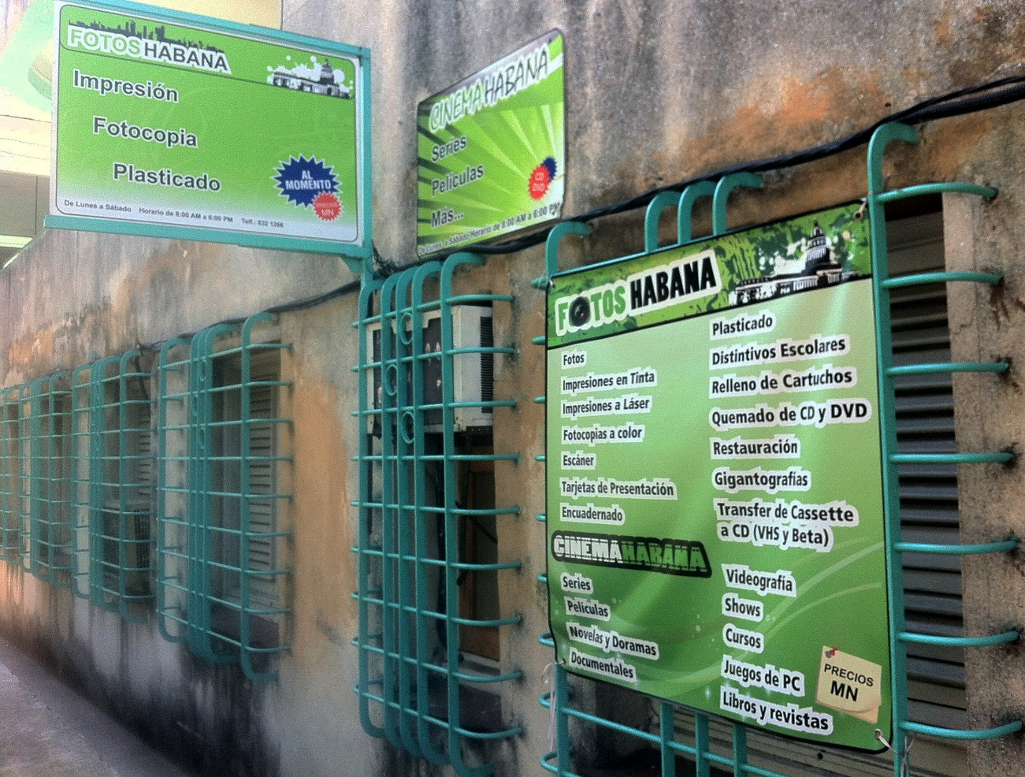

**Fig. 2. A private photocopying and printing business in Havana openly advertises pirated videos. Photo: Fidel A. Rodriguez**

The spread of *paquete* distribution has also led to the development of an advertising market, including unregistered advertising agencies. Digital publications generated exclusively for the *paquete* have multiplied. These publications cover topics underserved by the official Cuban press, including fashion and celebrity culture. Likewise, the *paquete* has also become a distribution space for locally-developed mobile apps. Even on state television broadcasts, the unique watermarks of certain *paquete* distributors can often be made out, revealing the origin of some of this content.

## Informal wireless networks

Another popular means of video distribution in Cuba is through urban wifi networks. Concentrated in Havana, but also found in other parts of the country, these illegal networks are organized by communities of video game players. While none of these networks are connected to the internet, they nonetheless have their own forums, social network sites, massive voice chats, streaming stations, and FTP servers for downloading pirated video. It is impossible to determine the number of users with any precision, but the number of users is large and growing. In early 2015, one of the network’s main sites had about 20,000 registered profiles. Complex forms of identity management and collective decision-making have evolved to regulate these networks.[18]

In these wifi communities, FTP content sharing is one of the most popular activities. Movies can be transmitted between different users in seconds. The weekly *paquete* is often available for download, thanks to an agreement with (and agreed payment to) the distributors. Some forms of local user-generated content are also available, including machinima, parody videos, flash mobs and remixes. FTP sharing etiquette is informally regulated, and has become a source of controversy within the community. Inappropriate downloading behavior can lead to a user being temporarily ‘banned’ through IP address blocking.

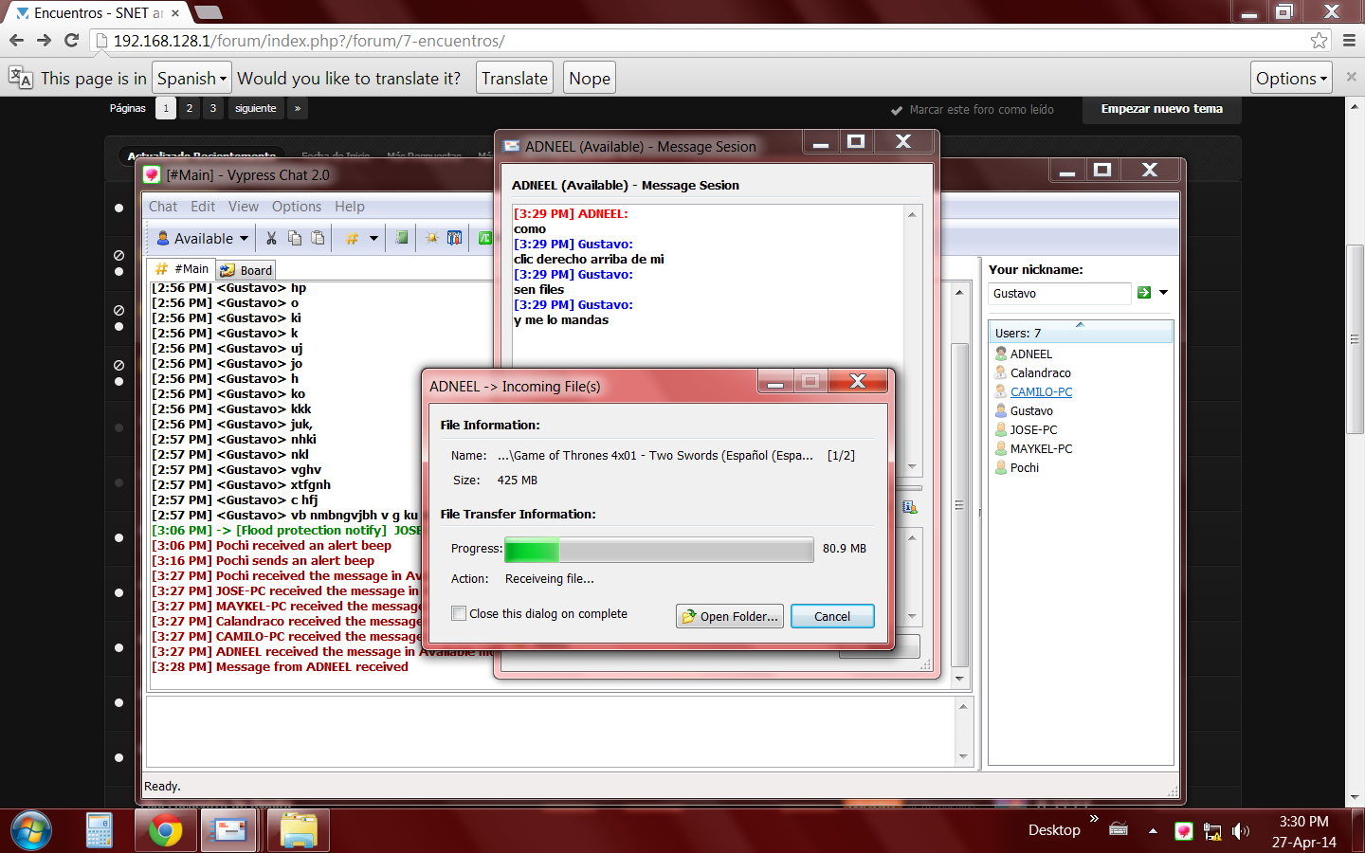

Fig. 3. A *Game of Thrones* file transfer on an informal wireless network

The network is also used to check the scores of European football league matches. While the Cuban TV networks regularly broadcast live Bundesliga matches, along with some other leagues, a number of very popular teams can only be viewed in delayed broadcast. As a workaround, certain users of the wifi networks (those with internet or satellite TV access) upload short videos and game highlights from the broadcast, captured with their cell phones aimed at the TV screen.

Because of its illegal nature, this infrastructure is hidden. To keep a low profile, the community forbids commercial activities on the network. Internet-access sharing is also forbidden, along with political or religious debate. Except for some cases of commercial trading of internet access, the Cuban authorities have tolerated the existence of these networks. It is understood that the police have even offered protection when network hardware has been stolen (a common occurrence). Informal networks such as these are still illegal under Cuban law, but a range of evidence – including leaked documents, public statements by officials, and similar experiments by state authorities – suggest that this kind of network may have a place within official ICT and internet policy in Cuba.

## Transnational ways to see: video and the diaspora

With a large community of Cuban immigrants in the United States, Canada, Latin America and Europe, transnational articulation of family ties is one of the most important social dynamics in the daily life of Cubans. Given the high cost of telephone calls and restricted internet access, communicating with family abroad can be a challenge. In 2015, a call to the United States cost about 88 cents a minute. In response, there is a longstanding tradition of asynchronous video exchange with the family through video letters and YouTube video uploads.[19]

It is therefore not surprising that Cubans are experimenting with online chat, using the aforementioned urban wifi networks as a means of access. Aside from Facebookvideo chat, the most widely used is the Chinese tool IMO for its low bandwidth requirements and high speed. Today, wifi-connected public spaces in Havana are full of people video chatting with family abroad (even though these users would probably prefer a more private environment). Software tools like IMO are usually shared among users through another popular Bluetooth application, Zapya, which is also frequently used for organized file-sharing meet-ups in parks and public spaces. In contrast, Skype is difficult to use in Cuba, as it is blocked to preserve the monopoly of the national telephone company. Those Cubans who do use Skype typically do so through VPN subscriptions maintained by friends and family outside Cuba.

Family ties are also strengthened through transnational consumption of Cuban music and culture. From Youtube to VOD sites, the proliferation of online streaming spaces provides access to Cuban-produced content for audiences outside Cuba. This system of video sharing is a response to the lack of an official streaming service for Cuban television, and the limited understanding of audiences outside the country.

Despite the access challenges, these forms of transnational video culture are increasingly widespread in Cuba. Video streaming is not practiced in the same way as in other countries, but the Cuban digital mediascape is nonetheless full of emergent forms of digital video consumption and communication that make efficient use of limited infrastructure.

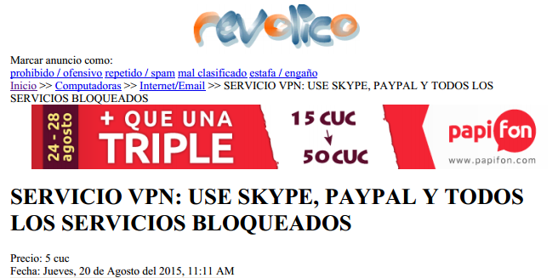

Fig. 4. A VPN advertisement in Revolico.com

## The future

The diverse video practices described above are taking place in a context of rapid political and economic transformation in Cuba, particularly with regards to communication. For example, Netflix’s announcement in 2015 that it would soon open its services to Cuban customers – even before it was available in major markets like Spain – crystalized some of the new scenarios associated with the normalization of diplomatic relations with the United States. But it also exposed the contradictions of digital culture in Cuba. Even though no Cubans could realistically access Netflix, due to the lack of credit cards and high-speed internet access, they were nonetheless already able to view all the latest *House of Cards* episodes through the multiple circulation methods described above.

Within these transformations, copyright will become increasingly important as a cultural policy issue. Interestingly, copyright enforcement in Cuba seems to have faded as a priority for the United States, as evidenced by the country’s disappearance from the Special 301 list of most-infringing nations. At the same time, Cuban producers of media and commodity goods, such as tobacco and rum, have become more interested in actively exploiting their trademarks overseas. In September 2015 the major record label in Cuba, EGREEM, signed an agreement with Sony Music giving them global distribution rights to the entire EGREEM catalogue – the most important in the country. These developments reflect a changing attitude to copyright in Cuba. They may also entail new restrictions in the digital distribution of Cuban content, such as the many unauthorized YouTube uploads of Cuban recording artists which may now be subject to takedown requests by Sony.

While restricted internet access is a fact of life in Cuba, diverse circulatory practices provide effective workarounds for these blockages. The cultural consequences of this informal infrastructure are significant. Looking ahead, we may start to see a different kind of Cuban communication policy emerging, one that transcends a focus on containment and regulation, and instead uses the creative potential of an open, networked culture of circulation. Cuba now has the opportunity to pursue an alternative path of socioeconomic and cultural development, in line with the revolutionary project, but not limited by copyright trade guidelines or government restrictions.

## References

Abad, Karina. *La piratería en Cuba*, Law School, Guantánamo University, 2013, Cuba, http://caribeña.eumed.net/wp-content/uploads/pirateria-cuba.pdf.

Barrera, Yanet. *La revuelta del espectador. Estudio exploratorio sobre el consumo mediático alternativo*, MA Thesis, Havana University, Cuba, 2009.

Cabrera, Cinthya. *Rutas USB. Acercamiento a la gestión de contenidos audiovisuales en el formato Paquete que realizan actores no institucionales en redes informales en La Habana,* Bachelor Thesis, Havana University, Cuba, 2015.

Calzadilla, Carlos Marcos. *Contar la Isla en videos. Un acercamiento a los rasgos que caracterizan el discurso sobre familias transnacionales cubanas a través de videos de usuarios no profesionales en YouTube*, Bachelor Thesis, Havana University. Cuba¸ 2014.

Castañeda, Dayne and Daynet Fonseca, *Teleadictos: conquistando la TV por la izquierda. Aproximación a la construcción de sentidos a partir del consumo mediático informal de programas audiovisuales en el asentamiento precario San Pablo en Santiago de Cuba,* Bachelor Thesis, East University, Cuba. 2014.

Concepción, José Raúl. *La cultura empaquetada: Análisis del consumo audiovisual informal del Paquete semanal en un grupo de jóvenes capitalinos*, Bachelor Thesis, Havana University, Cuba, 2015.

Díaz, Elaine and Firuzeh Sokooh, ‘Internet y las TIC en Cuba: Notas Para un Debate Sobre Políticas Públicas, *Temas*, La Habana, 2013, www.temas.cult.cu/revistas/74/08%20elaine.pdf.

Echemendía, Isabel, *Copi@ y Comp@rte una vez a la semana. Acercamiento a los principales rasgos que caracterizan el consumo audiovisual informal del Paquetes Semanal en dos grupos de jóvenes de la capital de Mayabeque*, Bachelor Thesis, Havana University, Cuba, 2015.

González, Félix*. Usos de los videojuegos en redes inalámbricas informales en La Habana*, Bachelor Thesis, Havana University, Cuba, 2015.

International Telecommunication Union. ‘Measuring the Information Society Report’, Geneva, Switzerland 2014, http://www.itu.int/en/ITU-D/Statistics/Documents/publications/mis2014/MIS2014_without_Annex_4.pdf.

Linares, Cecilia et al. *El consumo cultural y sus prácticas en Cuba*, Cuban Institute of Cultural Investigation Juan Marinello, La Habana, Cuba, 2009.

Márquez, Vanessa. ‘El consumo del Paquete Semanal en La Habana’, Social Research Center, Instituto Cubano de Radio y Televisión, unpublished version, 2015.

Moloney, Patricia. ‘Promoting Global Internet Freedom: Policy and Technology’, Congressional Research Service, 2013, https://www.fas.org/sgp/crs/row/R41837.pdf.

National Statistics Office. ‘Tecnologías de Información y las Comunicaciones: Indicadores Seleccionados’, 2015, http://www.one.cu/ticis2014.htm.

Pertierra, Anna Cristina.‘Private Pleasures: Watching Videos in Post-Soviet Cuba’, *International Journal of Cultural Studies* 12.2 (2009): 113-130.

_______. *Cuba: The Struggle for Consumption*, Coconut Creek, FL: Caribbean Studies Press, 2011.

________. ‘If They Show “Prison Break” in the United States on a Wednesday, by Thursday It Is Here: Mobile Media Networks in Twenty-First Century in Cuba’*,* *Television and New Media* 13.5 (2012): 399–414.

Recio, Milena. ‘La hora de los desconectados. Evaluación del diseño de la política de “acceso social” a Internet en Cuba en un contexto de cambios*.*’ *Bimestre Cubana* 116.4 (2014), http://www.bimestrecubana.cult.cu/ojs/index.php/revistabimestre/article/viewArticle/177.

Toirac, Yanet. *Política cultural:* *Una propuesta de enfoque comunicológico para su estudio*, PhD diss., Havana University, Cuba, 2009.

1. Yanet Toirac, *Política cultural:* *Una propuesta de enfoque comunicológico para su estudio*, PhD diss., Havana University, Cuba, 2009.
2. Anna Cristina Pertierra, *Cuba. The Struggle for Consumption*, Coconut Creek, FL: Caribbean Studies Press, 2011.
3. Anna Cristina Pertierra*,* ‘Private pleasures: Watching videos in Post-Soviet Cuba’, *International Journal of Cultural Studies* 12.2 (2009): 113-130.
4. Karina Abad, *La piratería en Cuba*, Law School, Guantánamo University, 2013, Cuba,

   http://caribeña.eumed.net/wp-content/uploads/pirateria-cuba.pdf.
5. Yanet Barrera, *La revuelta del espectador: Estudio exploratorio sobre el consumo mediático alternativo*, MA Thesis, Havana University, Cuba, 2009.
6. National Statistics Office, *Tecnologías de información y las comunicaciones: Indicadores seleccionados*, 2015, http://www.one.cu/ticis2014.htm.
7. Milena Recio, ‘La hora de los desconectados. Evaluación del diseño de la política de “acceso social” a Internet en Cuba en un contexto de cambios’, *Bimestre Cubana* 116.41 (2014), http://www.bimestrecubana.cult.cu/ojs/index.php/revistabimestre/article/viewArticle/177.
8. Milena Recio, ‘La hora de los desconectados’*.*
9. Elaine Díaz and Firuzeh Sokooh, ‘Internet y las TIC en Cuba: Notas para un debate sobre políticas públicas’, *Temas* 2013, www.temas.cult.cu/revistas/74/08%20elaine.pdf.
10. Patricia Moloney, ‘Promoting Global Internet Freedom: Policy and Technology’, Congressional Research Service, 2013, https://www.fas.org/sgp/crs/row/R41837.pdf.
11. Milena Recio, ‘La hora de los desconectados’.
12. National Statistics Office, ‘Tecnologías de información y las comunicaciones’.
13. This has been documented by a number of researchers. See: Yanet Barrera, Yanet *La revuelta del espectador. Estudio exploratorio sobre el consumo mediático alternativo*, MA Thesis, Havana University, Cuba, 2009; Cecilia Linares et al., *El consumo cultural y sus prácticas en Cuba*, Cuban Institute of Cultural Investigation Juan Marinello, La Habana, Cuba, 2009; Anna Cristina Pertierra, ‘If They Show “Prison Break” in the United States on a Wednesday, by Thursday it is Here: Mobile Media Networks in Twenty-First Century in Cuba’*,* *Television and New Media* 13.5 (2012): 399–414; Dayne Castañeda and Daynet Fonseca, *Teleadictos: Conquistando la TV por la izquierda. Aproximación a la construcción de sentidos a partir del consumo mediático informal de programas audiovisuales en el asentamiento precario San Pablo en Santiago de Cuba,* Bachelor Thesis, East University, Cuba, 2014; Cinthya Cabrera, *Rutas USB, Acercamiento a la gestión de contenidos audiovisuales en el formato Paquete que realizan actores no institucionales en redes informales en La Habana,* Bachelor Thesis, Havana University, Cuba, 2015; José Raúl Concepción, *La cultura empaquetada: Análisis del consumo audiovisual informal del Paquete semanal en un grupo de jóvenes capitalinos*, Bachelor Thesis, Havana University, Cuba, 2015; Isabel Echemendía, *Copi@ y Comp@rte una vez a la semana: Acercamiento a los principales rasgos que caracterizan el consumo audiovisual informal del Paquetes Semanal en dos grupos de jóvenes de la capital de Mayabeque*, Bachelor Thesis, Havana University, Cuba, 2015; Vanessa Márquez, *El consumo del Paquete semanal en La Habana*, Social Research Center, Instituto Cubano de Radio y Televisión, 2015.
14. It is estimated that around 80% of users access the *paquete* for free, by sharing with friends and family. Vanessa Márquez, *El consumo del paquete*.
15. José Raúl Concepción, *La cultura empaquetada.*
16. Cinthya Cabrera, *Rutas USB.*
17. Cinthya Cabrera, *Rutas USB.*
18. Félix González, *Usos de los videojuegos en redes inalámbricas informales en La Habana*, Bachelor Thesis, Havana University, Cuba, 2015.
19. Carlos Marcos Calzadilla, *Contar la Isla en videos. Un acercamiento a los rasgos que caracterizan el discurso sobre familias transnacionales cubanas a través de videos de usuarios no profesionales en YouTube*, Bachelor Thesis, Havana University. Cuba¸ 2014.